NOT FOR PUBLICATION WITHOUT THE
APPROVAL OF THE APPELLATE DIVISION

SUPERIOR COURT OF NEW JERSEY
APPELLATE DIVISION
DOCKET NO. A-0229-07T1

ANTHONY R. SUAREZ,

Plaintiff-Appellant,

v.

N.J.COM, PITA01, and MRCH0133,

Defendants,

and

VOTER 12345 a/k/a MICHAEL MECCA,

Defendant-Respondent.
_________________________________
June 27, 2008
Argued May 19, 2008 — Decided

Before Judges Lintner and Alvarez.

On appeal from the Superior Court of New Jersey, Law Division, Bergen County, Docket No. L-5546-05.

Andrew T. Fede argued the cause for appellant (Herten, Burstein, Sheridan, Cevasco, Bottinelli, Litt & Harz, L.L.C., attorneys; Patrick Papalia, of counsel; Carolyn B. Hand, on the brief).

Steven Siegel argued the cause for respondent Michael Mecca (Sokol, Behot and Fiorenzo, attorneys; Joseph B. Fiorenzo, of counsel and on the brief; Mr. Siegel, on the brief).

PER CURIAM
Plaintiff, Anthony R. Suarez, who during the relevant time was the mayor of Ridgefield, appeals from a July 31, 2007, award of summary judgment to defendant, Michael Mecca. Summary judgment was granted, because, among other reasons, the court found plaintiff failed to show any harm to his reputation, or damages, resulting from the claimed defamatory conduct. For the reasons that follow, we affirm.
Defendant, on July 21, 2005, using the login identification of "Voter12345," posted the following on the Ridgefield forum on an internet community website, N.J.com.:
I couldn't believe it! On Tuesday morning I received a loud continuous knock on my door at 6 am. I hurried to the door and I was confronted by police officers, Councilman Fucci and the Mayor. The told me that they were investigating an anonymous tip that I had an illegal apartment. After talking to them and showing credentials they told me they had made a mistake and were sorry. I understand that they should [investigate] all leads, but I am adamant that they should have gone about it another way. I also had a problem, that Fucci and the Mayor was [sic] there!! Kind of thinking that this was politically motivated! Has anyone else been confronted with this issue??

In subsequent posts to the Ridgefield forum on July 22 and August 3, 2005, defendant asserted that "[t]he facts are correct." At his deposition, however, he admitted that the alleged incident had been relayed to him by his attorney and friend, Marc Ramundo, then the Ridgefield municipal prosecutor, and had not actually occurred to him or to Ramundo. Defendant believed the story was true. The posting elicited several sympathetic comments from other participants on the Ridgefield forum message board.
Plaintiff denies that he was ever involved in any "raid" or "home inspection," and alleges that his political reputation has been harmed as a result of defendant's false posting. The complaint and two amended complaints followed; the second amended complaint was dismissed without prejudice as to all defendants other than Mecca, the only party to this appeal.
Defendant's first motion for summary judgment was denied because discovery, including depositions, had not been completed. The motion judge heard oral argument on July 20, 2007, on defendant's second motion for summary judgment, although plaintiff's deposition was scheduled for that afternoon pursuant to an order issued by a different judge. The motion judge allowed counsel a few days in which to supplement the record based on the anticipated deposition, and advised that he would render a decision in a week's time. Plaintiff did not appear at the scheduled deposition. He had previously submitted certifications from Louis V. D'Arminio, the mayor of Saddle Brook, and Phillip Ganci, a resident of Ridgefield, in support of his claim that the posting harmed his reputation. Both certifications stated in conclusory language that the posting diminished their view of plaintiff's reputation. It is not clear from the motion judge's decision if he considered the certifications in reaching his decision. Plaintiff also submitted his own certification, dated October 24, 2006, describing in equally conclusory terms the harm the posting inflicted upon his reputation. In that certification, plaintiff described defendant as "a political rival," and a "political enem[y] for some time."
Rule 4:46-2(c) provides that summary judgment should be granted where the "pleadings, depositions, answers to interrogatories, and admissions on file, together with the affidavits, if any, show that there is no genuine issue as to any material fact challenged and that the moving party is entitled to a judgment or order as a matter of law." As explained in Brill v. Guardian Life Ins. Co. of Amer., 142 N.J. 520, 540 (1995):
a determination whether there exists a "genuine issue" of material fact that precludes summary judgment requires the motion judge to consider whether the competent evidential materials presented, when viewed in the light most favorable to the non-moving party, are sufficient to permit a rational factfinder to resolve the alleged disputed issue in favor of the non-moving party. . . . The import of our holding is that when the evidence "is so one-sided that one party must prevail as a matter of law," [Anderson v. Liberty Lobby, Inc., 477 U.S. 242, 252, 106 S. Ct. 2505, 2512, 91 L. Ed. 2d 202, 214 (1986)], the trial court should not hesitate to grant summary judgment.

"'When reviewing the trial court's grant of summary judgment, this court uses the same standards as that court did and decides first whether there was a genuine issue of material fact, and if not, it then decides whether the trial court's ruling on the law was correct.'" Jolley v. Marquess, 393 N.J. Super. 255, 267 (App. Div. 2007) (citing Prudential Prop. & Cas. Ins. Co. v. Boylan, 307 N.J. Super. 162, 167 (App. Div.), certif. denied, 154 N.J. 608 (1998)).
Summary judgment is "well-suited" for defamation claims. Lynch v. N.J. Educ. Ass'n, 161 N.J. 152, 169 (1999) (quoting Dairy Stores, Inc. v. Sentinel Publ'g Co., Inc., 104 N.J. 125, 157 (1986)). As our Supreme Court has explained, "threat[s] of prolonged and expensive litigation [have] a real potential for chilling . . . criticism and comment upon public figures and public affairs," and may further "inhibit the full and free exercise of constitutionally-protected activities." Kotlikoff v. The Cmty. News, 89 N.J. 62, 67 (1982). Accordingly, trial courts are encouraged "to give particularly careful consideration to identifying appropriate cases for summary judgment disposition in this area of law." Id. at 67-68.
A public official, such as plaintiff, must show a defendant acted with "actual malice" in order to establish a prima facie case of defamation. N.Y. Times Co. v. Sullivan, 376 U.S. 254, 279-80, 84 S. Ct. 710, 726, 11 L. Ed. 2d 686, 706 (1964). This heightened standard is also applicable "when alleged defamatory remarks touch on a matter of public concern." Rocci v. Ecole Secondaire MacDonald-Cartier, 165 N.J. 149, 156 (2000). Actual malice in this context means a "plaintiff must establish by clear and convincing evidence that [a] defendant published [a] statement with 'knowledge that it was false or with reckless disregard of whether it was false.'" DeAngelis v. Hill, 180 N.J. 1, 13 (2004) (citing N.Y. Times Co., supra, 376 U.S. at 279-80, 84 S. Ct. at 726, 11 L. Ed. 2d at 706).
Even if we agree, as plaintiff contends, that defendant was acting in "reckless disregard" of the truth of the statement by publishing as his own, a story a third party obtained from an unknown source, and was therefore acting with actual malice, plaintiff must nonetheless prove damages. Plaintiff further contends that once having established actual malice, he is entitled to recover against defendant under the doctrine of presumed damages.
The doctrine of presumed damages in defamation cases has eroded over time. See McLaughlin v. Rosanio, Bailets & Talamo, Inc., 331 N.J. Super. 303, 317-20 (App. Div.), certif. denied, 166 N.J. 606 (2000). Presumed damages in slander cases are now generally limited to claims of slander per se. Ibid. The four categories of slander per se include allegations that a plaintiff (1) has committed a crime, (2) has a loathsome disease, (3) has engaged in conduct or has a condition or trait incompatible with his or her business, or (4) has engaged in serious sexual misconduct. Biondi v. Nassimos, 300 N.J. Super. 148, 154 (App. Div. 1997). The requirement that a claimant prove actual damages is waived in cases of slander per se because damage to one's reputation is "presumed" to flow from such statements, which are considered to cause injury in and of themselves. Ward v. Zelikovsky, 136 N.J. 516, 540. "[T]he slander per se doctrine has been criticized in recent years, resulting in the courts' refusal to expand any of these four categories or to invoke the doctrine unless it 'clearly' applies." Ricciardi v. Weber, 350 N.J. Super. 453, 476 (App. Div. 2002) (quoting McLaughlin, supra, 331 N.J. Super. at 319), certif. denied, 175 N.J. 433 (2003). The internet posting does not fit into any of the four slender per se categories.
Presumed damages were previously generally available in libel cases; however, the availability of such damages was limited in Sisler v. Gannett Co., Inc., 104 N.J. 256, 281 (1986). There, the court explained a plaintiff's burden of proving such general, as opposed to special — — or pecuniary — — damages:
Injury to reputation, even more so than personal injury or mental anguish, which are both amenable to expert testimony, defies exact measurement. The type of direct testimony lacking here has traditionally been hard to produce; in fact, it was this difficulty that engendered the "presumed damages" doctrine. However, the inherently amorphous quantification of libel damages potentially enables juries to vary damages awards in accordance with the popularity or unpopularity of the speaker or the view expressed. Accordingly, a plaintiff should offer some concrete proof that his reputation has been injured.

[Ibid. (emphasis added and citations omitted).]

Regardless of whether the internet postings are characterized as slander or libel, plaintiff cannot avail himself of the "presumed damages" doctrine. The statement does not fit into any slander per se category. After Sisler, a claimant in a libel suit must prove more than the amorphous damage to reputation plaintiff alleges here. See Ward, supra, 136 N.J. at 540. Therefore, the doctrine of presumed damages simply does not relieve plaintiff of the requirement that he establish reputational harm or actual damages.
Furthermore, where the allegedly defamatory remarks raise an issue of public concern, as does this case involving the public conduct of an elected official, a heightened standard of proof of damages is applied. Rocci, supra, 165 N.J. at 159. Matters of public concern are "at the heart of the First Amendment and thus require[] enhanced protection." Ibid. In such circumstances, a plaintiff must provide "'substantial evidence'" of reputational harm to satisfy the clear and convincing standard, and to survive a motion for summary judgment. Ibid. (quoting Costello v. Ocean County Observer, 136 N.J. 594, 615 (1994)).
Plaintiff failed to meet this heightened standard of proof. All three certifications, including his own, offered nothing but conclusory statements. This is a far cry from the detailed information as to plaintiff's diminished reputation required by Ward, supra, 136 N.J. at 540 or by Rocci, supra, 165 N.J. at 158-59. The certifications uniformly characterize the posting as harmful to plaintiff's reputation without detailing anything more. See Sisler, supra, 104 N.J. at 281 ("[A] plaintiff should offer some concrete proof that his reputation has been injured."). Plaintiff has not supplied any clear and convincing evidence of reputational harm or actual damages necessary to defeat a motion for summary judgment in matters of public concern. Rocci, supra, 165 N.J. at 159.
In summary, even if we presume that defendant acted with actual malice, plaintiff has failed to prove any damages. Since he cannot rely on the doctrine of presumed damages, summary judgment was properly granted.
In light of our decision that plaintiff has failed to prove damages, we need not reach the other issues raised for our consideration. Affirmed.

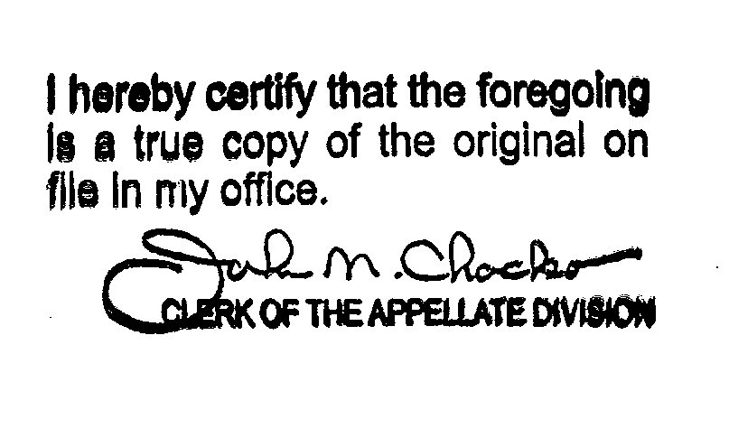

Plaintiff's second amended complaint lists this defendant as MRCHOI33. The listing of this party as "MRCHO133" in the appeal appears to be a typographical error.
Plaintiff is still the mayor of Ridgefield.

